Prototype

# The main page:

# Inventory page

# Customer page

# Receipt page

# 

# Quantity control page

Employee’s page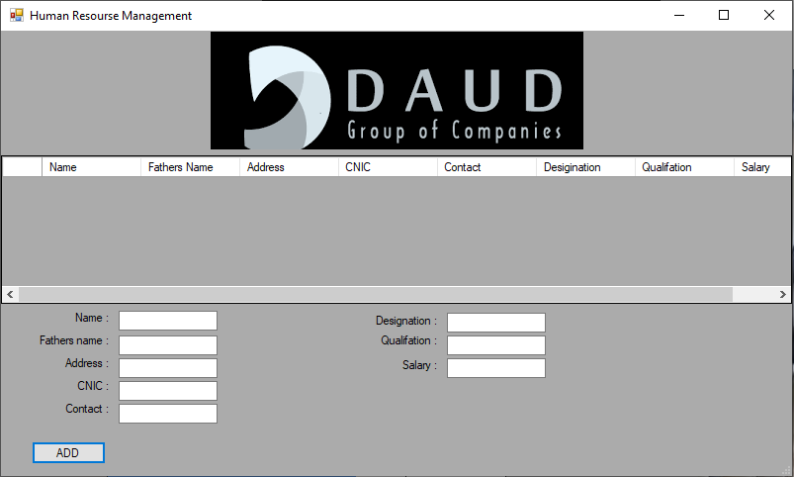

# Orders page

# Sales page

# Expenditure page

# Reports page

Raw material page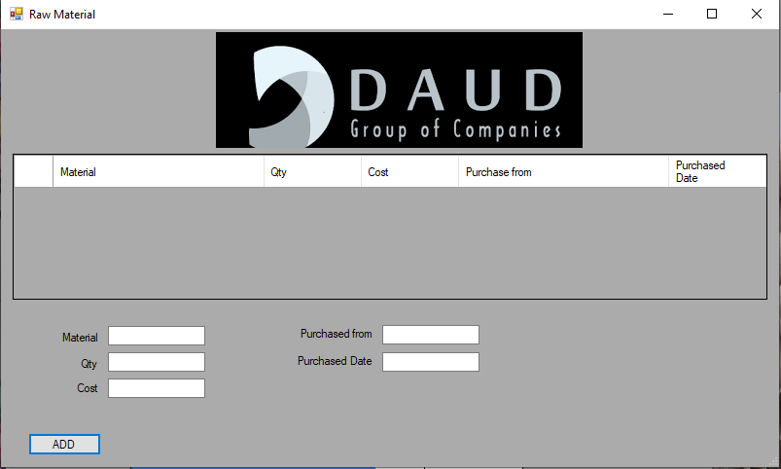

Formulation page